EX NO : 7 SECURE NETWORK ARCHITECTURE ROLL NO : 231901027

DATE : 13.4.2025

AIM:

Learn about and implement security best practices for network environments.

TASK 2 : NETWORK SEGMENTATION

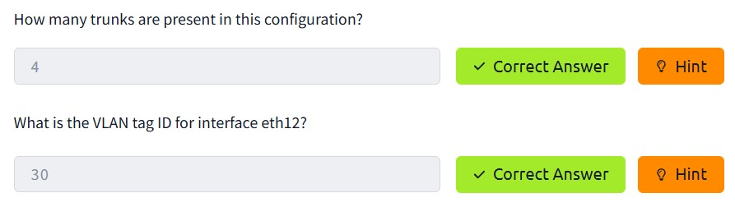

TASK 3 : COMMON SECURE NETWORK ARCHITECTURE

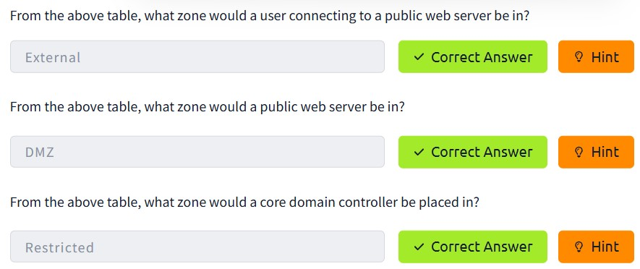

TASK 4 : NETWORK SECURITY POLICIES AND CONTROLS

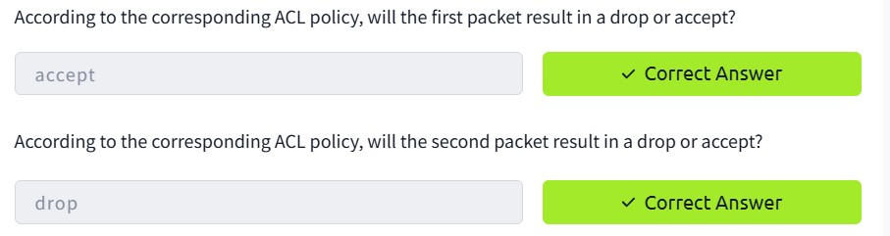

TASK 5 : ZONE-PAIR POLICIES AND FILTERING

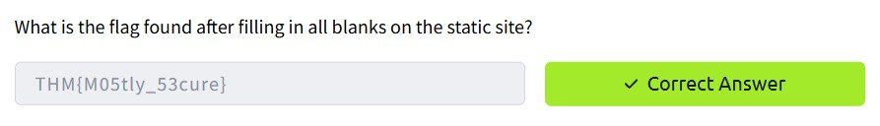

TASK 6 : VALIDATING NETWORK TRAFFIC

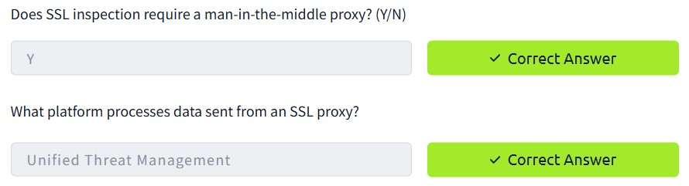

TASK 7 : ADDRESSING COMMON ATTACKS

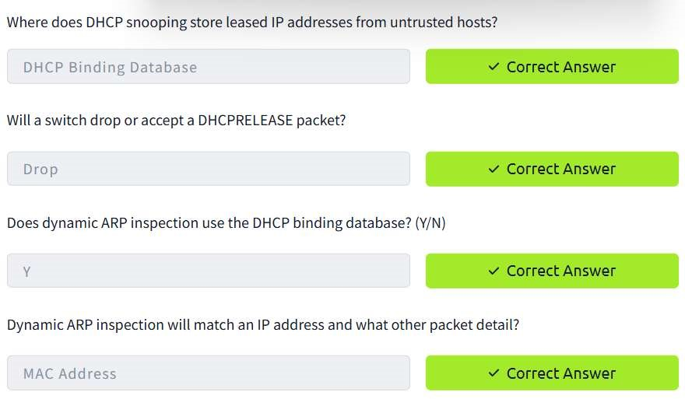

CONCLUSION :

Tryhackme platform secure network architecture task is successfully executed.s